Concept Note
Mongolia’s preparation for the SDGs Summit:
National Forum for Sustainable Development

Background
At the mid-way point of the 2030 Agenda for Sustainable Development, it is time to face the facts. Without a surge in commitment, solidarity, and transformative action, we will miss the headline targets of the 2030 Agenda to end poverty, reduce inequality and protect the environment. The Sustainable Development Goals (SDG) Summit to be held in September 2023 provides a unique opportunity to fundamentally change course.
The multiple crises of the last three years have dealt a major blow to SDGs implementation efforts. Millions have been pushed into poverty. Inequalities have risen considerably. The rights of women and girls have been under siege. And the urgent and existential business of averting climate catastrophe has been undermined.
Even before these crises hit, we were not on track to meet the goals by 2030. Many critical policy changes, innovations, transitions and investments have not advanced at the speed or scale required. And on every front – COVID-19, Climate Action, SDG financing – the international community has not done enough to give the most vulnerable countries a fair chance. Yet, the transformation envisioned by the 2030 Agenda remains both possible and essential.
Throughout history, humanity has demonstrated its capacity to overcome the most severe challenges. We can also draw confidence from the fact that we have never had access to so much knowledge, technologies and resources.
What is needed now is a surge in commitment from governments and stakeholders to take implementation to the next level. Under the leadership of the President of the General Assembly, the SDG Summit provides the platform we need to secure this commitment. The UN Secretary General (UNSG), therefore, urge all countries to come together around a Rescue Plan for People and Planet, based on deliverables by September on three key fronts.
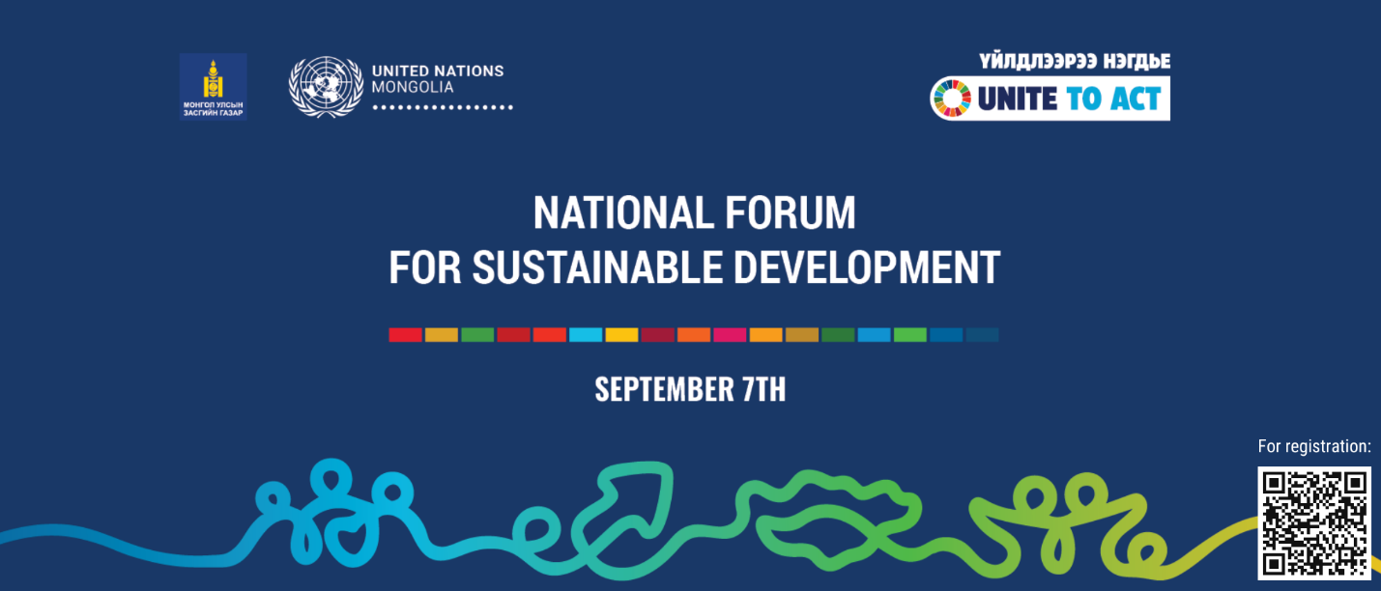
First, decisive action must be taken to better support developing countries. It is essential that the Political Declaration of the Summit signal an unambiguous commitment from the international community to reform the international financial architecture and ensure an enabling environment for developing countries to actively participate in and benefit from the global economy and harness the full potential of green and digital technologies.
Second, at the Summit, the UNSG urge world leaders to convey a National Commitment to SDG Transformation. This could include clear benchmarks to reduce domestic poverty and inequality levels by 2027 and 2030, in tandem with nationally determined climate contributions. Policy commitments to drive the energy, food, digital and social transitions that will make those benchmarks possible could also be outlined. Foundational actions to align national budgets with the SDGs, mainstream gender equality and empowerment of women and girls into national development planning processes, rejuvenate public sector capacities and institutions, and strengthen national data and monitoring systems could also be addressed.
Third, delivery of the 2030 Agenda requires the strengthening of public trust and the full participation of a wide range of stakeholders. The UNSG urge all countries to fully engage their domestic constituencies, particularly civil society and the private sector, in their Summit preparations. The United Nations system will complement national efforts by mobilizing support from all partners around select high-impact initiatives and advancing a more robust embrace of the Goals by businesses, local authorities and other actors.
The SDG Summit will be the centrepiece of a suite of events that include a Climate Ambition Summit, a Financing for Development High-level Dialogue, a series of health-related meetings and a Ministerial level meeting in preparation for the 2024 Summit of the Future. The SDG Summit can become a moment for our world to pivot from fear to hope and from deepening pessimism to accelerated action.
Mongolia’s preparation
In order Mongolia to prepare for its participation to the SDGs Summit delivering Mongolia’s National Commitment for SDGs Accelerations for advancing the SDGs by 2030, the Government of Mongolia led by Ministry of Economy and Development (MED) identified the national SDGs Accelerators and drafted the Mongolia’s National Commitment to be presented at the SDGs Summit.
The draft National Commitment including the Mongolia’s SDGs Accelerators are being consulted with various stakeholders with support of UN Mongolia to hears their voices. MED will be reflecting feedback from the stakeholders for finalizing the National Commitment to be presented at the SDGs Summit.
Stakeholder Dialogues
UN Agencies are supporting the Government of Mongolia/MED for organizing the stakeholder dialogues allowing MED to present and consult the proposed draft National Commitments including the SDGs Accelerators of Mongolia with the different stakeholders. Following specific dialogues were held during 17-22 August 2023:
- Dialogue with Private Sector representatives - supported by UNDP, UNICEF on 17 August’23
- Dialogue with Youth – supported by UNFPA, UNICEF ILO, on 17 August’23
- Dialogue with Development Partners – supported by Resident Coordinators Office, on 21 August’23
- Dialogue with Academia – supported by UNICEF, UNDP, UNESCO on 22 August’23
- Dialogue with CSOs - supported by UNDP, UNICEF on 22 August’23
- Dialogue with Local (provinces) representatives – supported by IOM, on 22 August’23
National Forum for Sustainable Development
National Forum for Sustainable Development involving high-level decision makers, practitioners, representatives from different stakeholders are planned to be jointly organized by Ministry of Economy and Development of Mongolia and the UN Resident Coordinator’s Office in Mongolia on 7 September 2023. Number of national companies who are contributing Mongolia’s efforts for sustainable development are supporting the forum event and showcasing their excellent initiatives for sustainable development during the event.
Selected representatives/rapporteurs from stakeholders consultations (one from each) will be invited to the panel discussion at the Forum for bringing voices from stakeholder dialogues.
The Government of Mongolia/MED will present and aim to have a national consensus on the proposed/revised National Commitments at the Forum in the end.
SDGs Action Campaign
The UN calls for global actions to accelerate achieving SDGs. In the lead up to the SDG Summit, the UN organizes a Global Week to #Act4SDGs. To support this global campaign and amplify the message of the urgency to act for SDGs in Mongolia and to mobilize more collective and individual actions for SDGs, the UN in Mongolia spearheads a “SDC Action Campaign” in Mongolia. Through this campaign, the UN Mongolia, together with its key partners, proposes to engage with the Mongolian communities, especially the private sector, and public in Ulaanbaatar city, in a range of activities and events geared towards advocating and promoting SDGs while acknowledging good deeds and achievements towards SDGs and to inspire sustainable behaviors and lifestyle and mobilize more commitment from businesses, communities and the wider public to the promotion of SDGs in Mongolia.

The campaign will also provide a space for inspiration and mobilization for further actions and commitment towards SDGs, giving a voice and space for the public to learn and get inspired to make positive changes in their personal and collective behavior and sustainable footprint.

This campaign primarily focuses on:
- Youth engagement for SDGs
- Public outreach and call to action on SDGs around the SDG National Forum

Focal persons for the Forum:
Ministry of Economy and Development and the Ministry of Foreign Affairs of Mongolia are the focal Ministries leading the preparation process within the Government. The President of Mongolia expressed his strong support for Mongolia’s preparation for the Summit.
Focal persons:
MED:
Balchinluvsan Lkhagvasuren, DG of the Integrated Policy Coordination and Planning Department, MED balchinluvsan.l@med.gov.mn;
Mungunsukh Batchuluun, Head of Social Policy Division, MED mungunsukh.b@med.gov.mn;
Enkh-Munkh Otgontogtokh, Officer, Integrated Policy Coordination and Planning Department, MED enkhmunkh.o@med.gov.mn
MFA:
Mandkhai Batsuren, DG, Multilateral Coordination Department, MFA dep06-1@mfa.gov.mn
Gereltsetseg. B, Adviser, Multilateral Coordination Department, MFA, dep06-5@mfa.gov.mn
UN Resident Coordinator’s Office (RCO):
Doljinsuren Jambal, Strategic Planner and Head of RCO, doljinsuren.jambal@un.org
Soyolmaa Dolgor, Communications and Advocacy Officer, RCO, soyolmaa.dolgor@un.org (focal person for SDGs Action Campaign)
Naran Otgonbayar, Administrative Associate, RCO, naran.otgonbayar@un.org (focal person for logistics)

Agenda of the Forum
Time | Activity
08:30 – 09:00 | Registration
09:00 – 09:15 | Opening remark  - KHURELSUKH UKHNAA, President of Mongolia
09:15 – 09:20 | Video presentation: Progress of the Sustainable Development Goals
09:20 – 09:40 | Mongolia for Sustainable Development  - KHURELBAATAR CHIMED, Deputy Prime Minister and Minister for Economy and Development  - TAPAN MISHRA, UN Resident Coordinator for Mongolia
09:40 – 10:10 | Main presentation: National Commitment for Sustainable Development Goals
10:10 – 10:25 | Initiatives for Sustainable Development (Private sector)
10:25 – 10:50 | Coffee and tea break
10:50 – 11:50 | Plenary discussion: National Commitment for Sustainable Development Goals
11:50 – 12:00 | Closing remark

